QA Automation Framework
Software Architecture Document

This document contains proprietary information. No part of this document should be reproduced, stored, copied, or transmitted in any form including electronic, mechanical, photocopying or otherwise, without the express written consent of the document owner.
Table of Contents
1 Objectives 3
2 Scope 3
3 Introduction 3
3.1 Intro to the application specific SAD 3
4 Outermost Use Case View 3
4.1.1 Outermost Use Cases View 3
5 Deployment Architecture 4
6 Logical Architecture 5
6.1 Component View 5
7 Implementation Architecture 6
7.1 CVS Modules 6
7.2 3rd Party Libraries 6
7.3 Configuration 6
8 Infrastructure View 7
8.1 Security 7
8.2 Performance 7
8.2.1 Latency 7
8.2.2 Throughput and Capacity Planning 7
8.3 Redundancy 7
8.4 Error Recovery 7
8.5 Scheduled and Batch Jobs 7
8.5.1 Normal Process 7
8.5.2 Testing scheduled and batch jobs 7
8.6 Development Environment 8
8.7 Testing 8
8.8 Client Requirements 8
8.9 <Other infrastructure components for this system> 8
8.10 Support and Monitoring 8
8.10.1 Performance 8
8.10.2 Errors and warnings 8
9 Logical View – Selected Detail Designed 8
9.1 Sub-module or Feature X (e.g. Link Trail) 9
9.1.1 foo 9
9.1.2 bar 9
9.2 Sub-module or Feature Y 9
9.3 Sub-module or Feature Z… etc 9
9.4 Custom Taglibs 9
10 API information 9
10.1 Business layer APIs 9
10.1.1 Cure and User Activity Tracking API 9
10.1.2 Autopay APIs 9
10.1.3 Get Forecasted Minimum Payment Due API 10
10.1.4 Changes 10
10.2 DB Layer APIs 10
11 Future Considerations and Improvements 10
12 Revision History 10
13 <Revision History for changes to the Template> 10

Objectives
The purpose of this document is to provide overview of the architecture and high level design for QA automation framework.

The document should strive to be:
- Durable and robust
- Brief and readable
- Flexible
- Focused
Small and medium size future changes should only require very small changes in this document. Large changes or architecturally significant changes will of course have a large impact on the document.

Audience
The primary consumers of this document are the architect and QA engineering. Secondarily it will be useful to project managers, product managers and engineer to have a high level understanding of the systems

Scope
The document covers QA automation framework 1.0. The main focus of the project is to implement an integrated automation testing framework for QA to automate GUI system testing, testing account condition and web service testing.
This document should focus and on this particular application and only on the architecturally significant or high level design aspects. Trivial low level details and large boiler plate lectures on design or philosophy tend to obscure the important useful information and therefore should be purposely excluded.

Introduction

Intro to the application specific SAD
Often software architect documents look as the system under design from various perspectives or ‘views’. This document follows that general template. There are many, many different kinds of views to possibly look at. A few have been chosen to capture most of the key elements of the system, however there are certainly others.

- Use Case View – what the system is supposed to be doing
- Deployment View – how the structure of the hardware and software
- Logical View – the control flow and sequence of events in an application
- Implementation View – information about the software itself (where it is located in CVS, configuration items, etc)
- Infrastructure View - key supporting functionality for cross-cutting concerns (e.g. logging, security, performance)

Outermost Use Case View

Outermost Use Cases View
Below are the architecturally significant or outermost use cases involved in the system. Each use case must list the actor and the goal of that actor. Please also list any significant changes to the use cases for this release.

Important: This table is only meant to provide basic information for the highest level understanding of what the system does and NOT go into details.
Outermost Use Case | Application | Sample Use Cases | Changes for this release
FSCM BAT automation | FSCM | Register a CM/Login FSCM/ Make a payment
FSCM use case automation | FSCM | Submit eAutopay with various options
Affinity BAT automation | Affinity
Affinity use case automation | Affinity
BW web service testing automation | BW | Verify MPD in getUserData web service
BW global variable audit | BW | Audit MPD global variables in production

Deployment Architecture
Below are the architecturally significant software and hardware components of the system.
The automation scripts are deployed to multiple testing PCs. Each testing PC will install Jenkins slave. Jenkins master will be configured to run different test suites in different PCs.

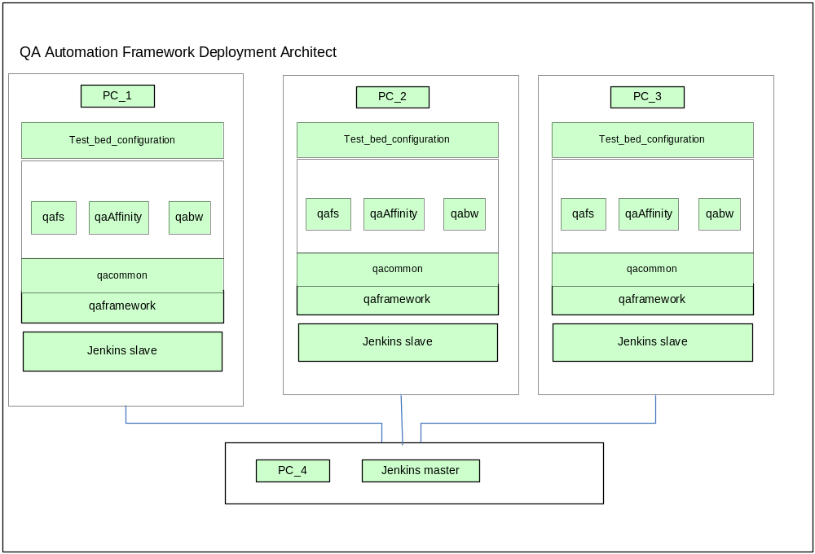

Logical Architecture

Component View
Below are the architecturally significant components of the qa automation framework
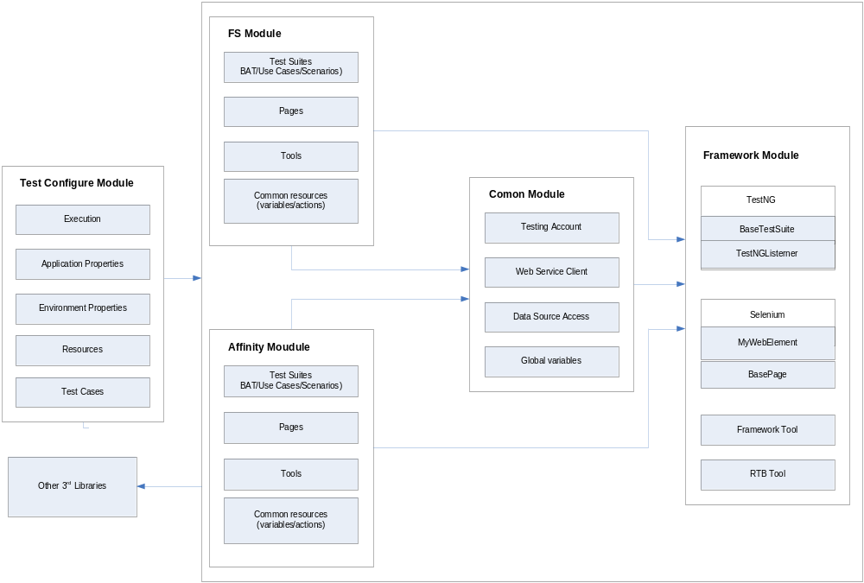

Implementation Architecture

CVS Modules
Primary Modules
CVS Module | Use | Location | Deployment | Changes
qaframework | qcommon,qafs, qaaffinity | ITO CVS
qacommon | qafs, qaaffinity | ITO CVS
qafs |  | ITO CVS
qaaffinity |  | ITO CVS

Secondary Shared Modules (modules used by other applications)
CVS Module | Use | Location | Deployment | Changes
Foundationbizprocess |  | SF CVS
Foundationservice |  | ITO CVS | foundation  service.jar

3rd Party Libraries
Below is a high level list of 3rd party applications and libraries used. The version of each of the libraries should NOT be maintained here as that is too much detail.
Library | Type | Use | Changes
jxl | Java JAR
webdriver | Java JAR
testng | Java JAR
spring | Java JAR
common-io | Java JAR
jsch | Java JAR

Configuration
The test_bed_configuration folder contains information on all of the configuration items for the automation framework. It will be used by QA to help configure the framework to run various test suits in various environments.

Location:
ID | Name | Description (including valid values, what each value does, and when each value should be used)
1 | execution | Test case/test suite specific configuration
2 | properties | General properties for all modules
3 | properties_fs | Properties just for qafs module
4 | properties_affinity | Properties just for qaaffinity module
5 | properties_qa | QA environment specific properties
6 | properties_stg | STG environment specific properties

Infrastructure View
This section covers key supporting functionality for cross-cutting concerns.
<In all of these sections fill in or update the section with application specific information >

Security
Please list any key security features of the system.
<fill in application specific information here>

Performance

Latency
Latency is how responsive the system is. How much time users have to wait.
<fill in application specific information here>

Throughput and Capacity Planning
Throughput and capacity planning deal with making sure that the required volume of events and data can be handled properly in the allotted time.

<fill in application specific information here>

Redundancy
All mission critical application must have a redundancy plan to ensure business continuity and disaster recovery. For most mission critical systems this also means they have redundant systems built in.

<fill in application specific information here>

Error Recovery
In general the application must be able to handle unexpected errors. This includes these principles
- Reasonable response to the end user
- Quick response to the end user
- Data left in a stable state – rolled back if needed
- Automatic recovery to normal system work flow when the root cause is resolved (e.g. automatically reconnecting to databases after they completed a restart).

<fill in application specific information here>

Scheduled and Batch Jobs
There will be the need for some nightly batch jobs to refresh some cached data and possibly do other work. Similar to other applications, this application will have a URL that can be hit to kick off the nightly jobs.
<fill in application specific information here>

Normal Process
In a normal production night, there will be a cron job that will request the URL then the app will perform the requested functionality.
<fill in application specific information here>

Testing scheduled and batch jobs
To kick off the job manually simply call the manual start URL.
<fill in application specific information here>

Development Environment
High level product specific info on Dev, QA, STG, PROD,

For a general discussion on the different environments, see:
$/Engineering/Development Process/Development Policy/Build, Deploy & SCM Policies/Build and Deployment Standards and Policies.doc

Testing
<fill in application specific information here>

Client Requirements
Requirement | Use
Browsers: Internet Explorer 6 | Used everywhere
Browser Configuration:  Active x controls  Xxx added to trusted sites list  Accepts cookies | Logging into the application
Attachmate Extra | Screen scraping the account number on the search page
Adobe Acrobat Reader | Display statements PDF

<Other infrastructure components for this system>

Support and Monitoring
In general most of our apps use a similar set of systems for monitoring. See the Enterprise SAD for more information on those systems. For more detail on this particular product, see the Product specific Ops Support document. However this section covers anything specific about the supportability design of this application? Anything specific designed in it for supportability.

Performance
How is the system performance monitored and how different from the typically 1fbusa system.

Errors and warnings
How is the system performance monitored and how different from the typically 1fbusa system.

<fill in application specific information here>

Logical View – Selected Detail Designed
Only use this for the very top level components. See section 9 for more detailed components.
Sub System or Component | Brief Description
Link Trail
Data Locker
College Data DB
External Colleges Data Load | College data from …

Sub-module or Feature X (e.g. Link Trail)
<use this area to fill in more info about architecturally interesting parts of the application. Be sure to use UML or other pictures when approapriate>

foo
<use this area to fill in more info about architecturally interesting parts of the application. Be sure to use UML or other pictures when approapriate>

bar
<use this area to fill in more info about architecturally interesting parts of the application. Be sure to use UML or other pictures when approapriate>

Sub-module or Feature Y

Sub-module or Feature Z… etc

Custom Taglibs
This section should document any custom tag libs
Custom Tag | Raw HTML Tag | Description
<onefbusa:text maxlength="20" property="userName" autocomplete="off"/> | <input type=”text” name=” text1”> | Tag creates the text field. The string is retrieved from and later stored in the property named text1 in the form bean.  Custom 1FB tag to accommodate autocomplete attribute not available in struts tag.

In addition the following taglibs are used by more than one application:
Tag | Applications
css | afcoll, afcsr, ccapp, fscm, fsagent

For information on 3rd party taglibs see the 3rd party libraries section above (under Implementation). Also see
- $/Engineering/Architecture/3rd Party Libraries and Tools/3rd Party Libraries.xls
- The Project Fundamentals document for this project (if there are changes to 3rd party taglibs)

API information

Business layer APIs

Cure and User Activity Tracking API
For information on the Program Cure and User Activity Tracking interfaces see:
FS 5.5 Program Cure API Design.doc

Autopay APIs
For information on the Autopay interfaces see:
$/Engineering/Architecture/Applications and Services/1fbusa API Master Lists/autopaybizprocessMasterAPIList.doc

Get Forecasted Minimum Payment Due API
For information on the Forecasted Minimum Payment Due interface see:
$/Engineering/Architecture/Applications and Services/1fbusa API Master Lists/1fbbizprocessMasterAPIList.doc

Changes
For changes to APIs for the project see:
… (list the api change request document)

DB Layer APIs
List the db APIs
$/FS/FSCM/Projects/old projects/FSCM 5.50 (ProgramCure)/Design/DB APIs/FS 5.5 DB Logging APIs.doc
$/FS/FSCM/Projects/old projects/FSCM 5.50 (ProgramCure)/Design/DB APIs/FS 5.5 DB Non-Logging APIs.doc

Future Considerations and Improvements
Optionally, if there are any notable aspects of the system that are in need of future improvement or refactoring.

Revision History
This should contain the updates to the SAD for this product. Be sure and always include the project information. Also be sure when you check it into VSS that the project # is added to the comments so that the SAD for a particular project can always be determined.

Date | Doc  Rev | Project | Description | Author
1/1/2009 | 0.1 | FS 6.0 | Initial version created from template | Grant Swanson
1/20/2009 | 0.5 | FS 6.0 | Updates for this project | Grant Swanson
2/12/2009 | 1.0 | FS 6.0 | Final updates for this project | Grant Swanson
4/4/2009 | 1.1 | FS 6.1 | Added, removed , updated, etc | Grant Swanson
12/28/2010 | 2.0 | FS 6.2 | Changes for this project | Grant Swanson

<Revision History for changes to the Template>
<This revision history is just for the template and is to be removed in the real SAD>
Date | Revision | Description | Author
3/25/07 to  12/31/09 | 0.1 to 0.9 | Initial versions. Small changes here and there | Grant Swanson
1/11/2010 | 1.0 | Update with some info learned on recent projects | Grant Swanson
5/14/2011 | 2.0 | Updated based on review with Sandra and comparisons to existing SADs. Also removed parts that will go in the enterprise SAD | Grant Swanson
6/17/2011 | 2.1 | Went over template with Retesh and considered parts to add to help cover the CS systems | Grant Swanson
7/8/2011 | 2.2 | Add more space for descriptions of sub modules in section 9 | Grant Swanson
10/24/11 | 2.3 | Added info about taglibs. Added a second revision history | Grant Swanson

